Embry-Riddle Aeronautical University

Student Government Association

Daytona Beach Campus

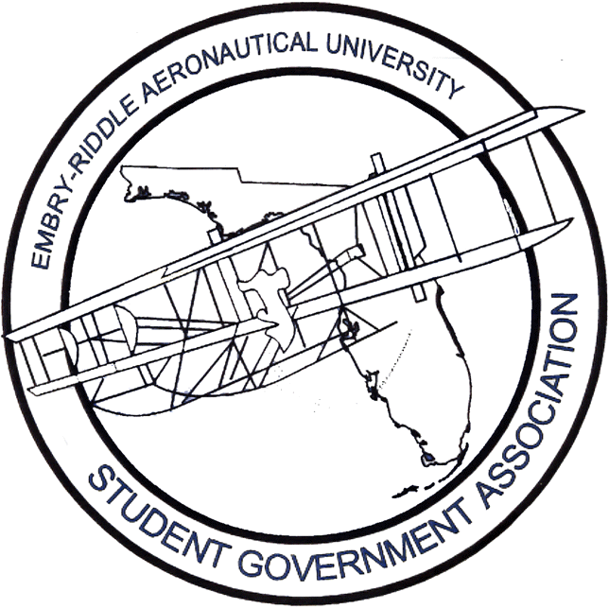

Report to the Board of Trustees

Fall 2004

Submitted by:
Matthew W. Collier
SGA President

Talking points…

When most students plan to attend college, they plan and budget expenses for the entire extent of the educational experience. In a considerable number of cases, these budgets are very tight, only allowing for a nominal variance. In fact, most students choose Embry-Riddle even though they may not be able to afford it – and with great optimism, hope that the finances will work out – all in an effort to attend the very best university for an aviation/aerospace education.

I think it would be appropriate for continuing students to pay a 2-3% ‘cost adjustment’ to cover increased operating costs such as utilities, goods and labor. New students are in a more suitable position to bear a substantial ‘tuition increase’ of 7-8% to generate funding for new initiatives – to this group, this is merely ‘sticker price’ and not considered a ‘tuition increase.’ The incoming class comprises nearly a third of the student population. However, when increasing tuition for new students, consideration must be given to the potential impact on selectivity and quality of students.

If a junior or senior with a tight budget is forced to pay more, and cannot find the extra financial aid, they may be left with no other choice but to transfer, whereas a new student would have the choice of whether or not to pursue an Embry-Riddle degree.

Additionally, if tuition is increased for continuing students, the university must take into account the potential impact on the climate and the level of satisfaction at graduation. There are currently no assessment tools in place to help gauge the impact of tuition increases on student satisfaction, and they would be rather difficult to create. Nevertheless, it would behoove the university a great deal to develop and implement these tools – and act on the results.

For years, the argument has been made that the seemingly never-ending tuition increases will discourage alumni from donating in the future. And for years, this argument has been discounted with no true evaluation of its veracity. As a young university, there will be no metrics until much further down the road, when it will be too late to correct the situation, and millions and millions of contributions will go unseen because of the reluctance to review the situation.

While not directly related to increasing tuition, it noteworthy that there is an apparent imbalance of revenue and spending as presented in the FY 2004-2005 Budget Presentation given in Boston.

The Daytona Beach campus is projected to generate $000.0M, which is nearly five million more than the previous year due to the tuition increase. At the same time, the FY05 budgeted expenditures for the DB campus have decreased approximately $000k from FY04 as a result of the admissions function valued at $0.0M being moved from DB. After making the aforementioned adjustments, DB realizes only $0.0M of the increase of $0.0M – which is less than fifty percent. In other words, the DB students are paying more, but not seeing even half of that money.

It is frequently alleged that the Extended Campus is a ‘cash cow’ and is more profitable than the residential campuses. This notion can be debunked by referring to the amount of each campus’ revenue that is contributed to administrative overhead:

- DB 30% with $00.0M
- PR 7.6% with $0.0M
- EC 9.4% with $0.0M

From a different perspective, the Daytona Beach campus contributes nearly 80% of the excess revenue that is unused at the campus level and subsequently allocated to the administration. Clearly, after examining these numbers, the conclusion can be reached that the university is driven by the Daytona Beach campus, and an emphasis should be placed on strengthening and leveraging this campus and its potential.

While many tuition increases may be warranted, in most cases, they are perceived as being unjustified, and therefore, result in concerns and strife. To that end, an open dialogue, a clearer budgeting process and a more transparent budget would help to mitigate negative responses, change the perception, and subsequently, garner more support from the general university community.

Concerning the student body…

Campus is relatively quiet these days. Students do not seem to be upset about any one particular issue aside from what was addressed in the last report. I have found that there is really no need repeatedly rewrite and wordsmith the issues that the student body is facing. For that reason, I’m just going to list some improvements and what continues to be matters of concern:

- Improved customer service
- Better communication with student leadership and student body
- Student Center Renovation project well received
- Series of hurricanes handled very well by the administration

- Campus still lacking a true Student Union
- Tuition increases and budget transparency
- Campus landscaping, particularly in student areas

SGA Executive Board

The Executive Board, which consists of Vice President Matt Tarnowski, Treasurer Liz Barber, and Chief Justice Jessica Johnson and myself, has been busy throughout the summer making preparations for the upcoming academic year. This year, we've placed emphasis on strengthening the student voice and also on enhancing communication both within the organization and within the student body. Executive Board meetings will occur on a weekly basis, and will include the Division Chairs and other invited guests.

To address communications and public relations needs, two new positions have been established and filled. Ashley Moore, the Director of Internal Affairs will be responsible for maintaining fluid communication within the Student Government and delivering that information to the campus community. Michael Vacirca, the Director of External Affairs will be responsible for the development and maintenance of the SGA website and maintaining active participation in the American Student Government Association. He will also serve as a liaison to other student governments within the State of Florida.

With so many of our members gone this summer, the Executive Board invoked the constitutional provision that allows all branches and divisions to be called together in joint session. Operation All Hands on Deck, as it became known, proved to be very beneficial and productive. The Operation examined a great deal of issues, including but certainly not limited to campus landscaping, diversity concerns and SafeRide.

The SafeRide Program is without question one of the most valuable services that Student Government offers the students at Embry-Riddle. Throughout the spring semester, we fielded a great deal of complaints and concerns relative to the performance of the program. In an effort to address those concerns, The Operation spent a significant amount of time evaluating the program and determining the best course of action. At this time, it would be unwise to publicly disclose the status due to contractual negotiations, but rest assured, the SGA considers this an absolute priority and will deliver a new and improved program very soon. Expect to see substantial and visible improvements this fall.

Each year, every department within the university undergoes a process known as strategic planning. This summer, the SGA joined the rest of the campus and invested a considerable amount of time planning for the upcoming academic year and beyond. The strategic plan will outline our mission statement, vision statement, a SWOT analysis and a comprehensive list of our goals and objectives.

The Branches and Divisions will be working closely with the Executive Board to finalize the goals and objectives from each respective area of the organization, and the final results will be posted on the website shortly thereafter. Through these efforts, we hope to establish a more defined vision that will provide direction for the year. We will also institute assessment tools to evaluate our progress towards achieving the goals and objectives in our efforts to fulfill the mission and vision of the organization.

The Student Representative Board is working diligently and has a great deal of new initiatives for the upcoming year. Specifically, Vice President Tarnowski hopes to make the Representative Board more visible by holding regular meetings on the Flight Deck and being sure that all meeting times and places are well publicized. Additionally, emphasis will be placed on soliciting student feedback to help determine areas of interest that need to be addressed.

The Student Finance Board has been busy hitting the books preparing the budget for the fall, and has approved funds for the handful of clubs and organizations that were active on campus for the summer. Treasurer Barber has held a series of meetings with the Director of Student Activities and the SGA Advisor to streamline the budgeting process to ensure that we are allocating and tracking funds as effectively as possible.

The Student Court has been unusually active this summer. Under the guidance of Chief Justice Johnson, the Associate Justices have outlined a plan to expand the court beyond its current primary function as the parking appeals board. Under the new plan, if a student encounters a judicial situation, they will be afforded the option of having their case heard before a board of peers comprising the applicable circuit court. Proposed circuit courts include: University Violations, Academic Violations, Student Issues, Housing Violations and Parking Violations. The idea is to encourage active engagement and self-governance among the student body. The proposal is awaiting the official endorsement of the Student Representative and Finance Boards, as well as the Dean of Students and other administration officials.

Avion Newspaper

The Avion Newspaper is geared up for one of its best semesters to date – with a staff of over fifty students. The Newspaper has invested a fair amount of time in revamping the overall purpose and appearance of the publication. The Editorial Board has met regularly to discuss issues such as layout, format, and number of sections.

It is the objective of this year’s staff to strive towards the establishment and maintenance of journalistic integrity, and impress this on every staff member. For example, a committee has been formed to discuss and develop a statement of principles, ethics and values to be applied towards any and all publications. It is important to recognize that while the Avion does not have the right to true freedom of the press, they do enjoy a pseudo-freedom that should not be compromised. Actively controlling or censoring the newspaper would harm the organization by the very nature of what they do – report the news in a fair and unbiased manor.

I am pleased to report that thus far, the Administration has been very supportive of the Avion, and I look forward to their continued support and understanding.

Also, through the Avion, Student Government is pursuing a new and exciting yearbook opportunity. After being approached by an outside company, we have decided to outsource most functions of yearbook production, which, in the past, have been responsible for the failure of the organization. The company will be responsible aspects such as financing, marketing, production and distribution, leaving the students to do what they do best – develop content.

Touch-N-Go Productions

Touch-N-Go is currently making preparations for homecoming weekend. At this time, improve comedy stars Colin Mochrie and Brad Sherwood of “Whose Line is it Anyway?” have been secured as the featured homecoming show.

It is important to note that Student Government funds nearly 75% of the activities on homecoming weekend, which, last year, totaled approximately $80,000. The University only budgets $15,000 to the Department of Student Activities for the entirety of homecoming. In fact, last year, facing a paucity of funds, Student Activities had to loan money from its operating budget to cover homecoming costs.

While Student Government prides itself in being a primary sponsor of homecoming activities, the opportunity cost is quite prodigious in terms of the applications of that money if it had been available for over 130 clubs and organizations on campus.

Our chancellor has assured us that next year’s budget will allow for significant increases to the homecoming allocation, and we are looking forward to the increased support. Other events planned for the semester include open microphones, comedians and a political debate to be hosted as the national elections approach draw near.

Eagle FM Radio Station

The radio station has concluded their negotiations with Bethune-Cookman, and has finalized, signed and submitted the application to the FCC for a low-power FM license. They are currently awaiting response from the FCC regarding the status of the application, but expect to be operational by the end of the fall semester. In preparation for broadcast, the SGA has made significant commitments to enhance the quality of their equipment and technology.

In addition to the FCC endeavor, WERU has been growing consistently throughout the semester as students become more and more interested and aware of the opportunities in this division. With a campus that is lacking in communications related activities, the radio station provides a vehicle through which interested students can find an outlet to express themselves.

